
DAYANANDA SAGAR COLLEGE OF ENGINEERING
(An Autonomous Institute affiliated to VTU, Belagavi, Approved by AICTE
Accredited by National Assessment & Accreditation Council (NAAC) with ‘A’ grade)
Shavige Malleshwara Hills, Kumaraswamy Layout, Bengaluru-111

DEPARTMENT OF INFORMATION SCIENCE & ENGINEERING
(Accredited by NBA Tier 1: 2025-2028)

INTERDISCIPLINARY PROJECT BASED LEARNING [1BPRJ208]
Mini Project Report
on
“Solar to Savings: Energy Conversion Using Solar Analytics for Material Efficiency”

Submitted in partial fulfilment for the award of the Degree of

Bachelor of Engineering
in
Information Science and Engineering

Submitted by
SAI VIDYA B V | 1DS25CV124
SHEIK MOHAMMED SUFIYAN | 1DS25CV139
SHISHIR R REDDY | 1DS25IS155
SHREYA A | 1DS25IS159

Second Semester B.E

Under the guidance of
Prof. Ayan Sadiqali Nadaf | Prof. Nitin Kumar
Associate Professor | Associate Professor
Dept. of ISE | Dept. of CV
DSCE, Bangalore | DSCE, Bangalore

VISVESVARAYA TECHNOLOGICAL UNIVERSITY
JNANASANGAMA, BELAGAVI-590018, KARNATAKA, INDIA
2025-26

DAYANANDA SAGAR COLLEGE OF ENGINEERING
(An Autonomous Institute affiliated to Visvesvaraya Technological University (VTU), Belagavi,
Approved by AICTE and UGC, Accredited by NAAC with ‘A’ grade)
Shavige Malleshwara Hills, Kumaraswamy Layout, Bengaluru-560 111, India

DEPARTMENT OF INFORMATION SCIENCE & ENGINEERING
(Accredited by NBA Tier 1: 2025-2028)


CERTIFICATE

This is to certify that the project report entitled “SOLAR TO SAVINGS: ENERGY CONVERSION USING SOLAR ANALYTICS FOR MATERIAL EFFICIENCY” is a bonafide work carried out by Sai Vidya B K[1DS25CV124], Sheik Mohammed Sufiyan[1DS25CV139], Shishir R Reddy[1DS25IS155], Shreya A[1DS25IS159] of DAYANANDA SAGAR COLLEGE OF ENGINEERING, in partial fulfilment of 2nd Semester, Bachelor of Engineering under Visvesvaraya Technological University, Belagavi during the year 2025-26. It is certified that all corrections/suggestions indicated for Internal Assessment have been incorporated in the report deposited in the Departmental library. The Project report has been approved as it satisfies the academic requirements with respect to the work prescribed for the said Degree.

Prof. Ayan Sadiqali Nadaf | Prof. Nitin Kumar | Dr. Annapurna P Patil | Dr. B G Prasad
Associate Professor | Associate Professor | Dean Academics & HoD | Principal
Dept. of ISE | Dept. of CV | Dept. of ISE | DSCE, Bangalore
DSCE, Bangalore | DSCE, Bangalore | DSCE, Bangalore

Name of the Examiners: Signature with date:
- .................................... ………………………………

- .................................... ……………………………….
ACKNOWLEDGEMENT
The satisfaction and euphoria accompanying the successful completion of any task would be incomplete without the mention of people who made it possible under constant guidance and encouragement. We sincerely thank the Management of Dayananda Sagar College of Engineering, Bengaluru.
We express our sincere regards and thanks to Dr. B G Prasad, Principal, Dayananda Sagar College of Engineering, Bengaluru. His constant encouragement guidance and valuable support have been an immense help in realizing this project.
We express our sincere regards and thanks to Dr. Annapurna P Patil, Professor & Head, Department of Information Science and Engineering, Dayananda Sagar College of Engineering, Bengaluru. Her incessant encouragement guidance and valuable technical support have been an immense help in realizing this project. Her guidance gave us the environment to enhance our knowledge, and skills and to reach the pinnacle with sheer determination, dedication, and hard work.
We would like to express profound gratitude to my guide Prof. Ayan Sadiqali Nadaf , Associate Professor, Department of Information Science and Engineering, and Prof. Nitin Kumar, Associate Professor, Department of Civil Engineering, Dayananda Sagar College of Engineering, Bengaluru who has encouraged us throughout the project. His moral support enabled us to complete the work successfully.
We express our sincere thanks to Project Coordinators Dr. Muzameel Ahmed, Associate Professor, Dr. Reshma J, Associate Professor and Mr. Bharath BC, Assistant. Professor, Department of Information Science and Engineering for their continuous support and guidance. We thank all teaching and non-teaching staff of the Department of Information Science and Engineering for their kind and constant support throughout the academic journey.
SAI VIDYA B K | 1DS25CV124
SHEIK MOHAMMED SUFIYAN | 1DS25CV139
SHISHIR R REDDY | 1DS25IS155
SHREYA A | 1DS25IS159

ABSTRACT
The increasing demand for sustainable energy solutions and energy-efficient buildings has led to the development of intelligent systems that integrate civil engineering principles with computational energy analytics. This project, titled “Solar to Savings: Energy Conversion Using Solar Analytics for Material Efficiency”, aims to design and implement a smart energy optimization framework for buildings. The main objective of the system is to optimize solar energy planning by reducing building energy demand through civil passive design techniques and accurately estimating solar photovoltaic (PV) system requirements. The system also focuses on financial feasibility and environmental impact analysis. The proposed methodology involves a multi-stage computational approach. Initially, user inputs such as monthly energy consumption, electricity tariff, and peak sunlight hours are collected. Civil engineering-based passive strategies such as cool roof coating and double-glazed window systems are applied to reduce baseline energy demand. The adjusted energy load is then used to calculate the required solar plant capacity, number of solar panels, and structural load on rooftops. Finally, financial analysis including installation cost, payback period, and carbon emission reduction is performed. The system produces key results such as optimized solar sizing, reduced energy consumption through passive design integration, accurate structural load estimation, and precise financial break-even analysis. The outcomes demonstrate improved efficiency in renewable energy planning and cost optimization. The system is applicable in smart city infrastructure, residential and commercial building energy auditing, and sustainable urban development planning. It supports decision-making for solar installation and green building design. The future scope of the project includes integration with IoT-based real-time energy monitoring systems, machine learning-based energy prediction models, and cloud-based multi-building energy optimization platforms. A limitation of the current system is that it operates in a client-side environment without real-time hardware sensor integration.
Keywords: Solar PV Optimization, Smart Buildings, Passive Design, Energy Analytics, Financial Modeling

TABLE OF CONTENTS

ABSTRACT |  |  | iii
LIST OF TABLES |  |  | vii
LIST OF FIGURES |  |  | viii
LIST OF ABBREVIATIONS AND SYMBOLS |  |  | ix
1. | INTRODUCTION |  | 01-05
 | 1.1 | Overview | 01
 | 1.2 | Problem statement | 02
 | 1.3 | Objectives | 03
 | 1.4 | Motivation | 03
 | 1.5 | Hardware and Software Requirements Specification | 04
 | 1.6 | Project budget plan | 05
2. | LITERATURE SURVEY |  | 06-08
3. | SYSTEM DESIGN & METHODOLOGY |  | 09-12
 | 3.1 | Proposed system | 09-10
 | 3.2 | Identified tools / Libraries / Software | 10-11
 | 3.3 | Architectural block diagram & corresponding system modelling | 11-12
4. | IMPLEMENTATION |  | 13-16
 | 4.1 | Overview of system implementation | 13
 | 4.2 | Module description | 14-15
 | 4.3 | Code snippets | 15-16
5. | RESULTS & DISCUSSION |  | 17-18
6. | CONCLUSION AND FUTURE SCOPE |  | 19-20
REFERENCES |  |  | 21
APPENDIX (IF ANY) |  |  | 22

LIST OF FIGURES

Figure No. | Description | Page No.
3.1 | Flowchart of Proposed System | 08
3.3 | Architectural block diagram & system modelling | 12
4.3.1 | Input, civil logic modification & solar plant size calculations | 18
4.3.2 | Indian market cost architecture | 18
4.3.3 | Populate Document value | 19
4.3.4 | System visual analytics charts | 19
4.3.5 | Text data audit exporter module | 19
6.1.1 | Dashboard along with user inputted data | 22
6.1.2 | Graphical Analysation | 23

LIST OF TABLES

Table No. | Description | Page No.
1.6 | Project Budget Plan | 05
2.1 | Literature Review | 06-08

Chapter 1

INTRODUCTION

Overview
- In recent years, the rapid expansion of urban infrastructure and increasing population density have led to a significant rise in global energy consumption. Buildings, both residential and commercial, contribute a major share of this demand due to continuous usage of electrical systems, heating, cooling, and lighting requirements. This growing dependency on conventional energy sources has resulted in environmental degradation, higher operational costs, and increased carbon emissions. As a result, there is a strong need for sustainable and intelligent energy management solutions.
- Solar energy has emerged as one of the most promising renewable energy sources for reducing dependence on fossil fuels. However, most existing solar energy estimation tools are based on static models that do not consider real-world structural and environmental factors such as building insulation, roof reflectivity, and glazing systems. These civil engineering parameters significantly influence energy consumption but are often ignored in conventional solar planning systems. Additionally, solar sizing tools generally do not integrate financial analysis or structural load considerations, leading to incomplete decision-making frameworks.
- To address these limitations, this project proposes an integrated Smart Solar Energy Optimization System that combines civil engineering concepts with computational energy analytics. The system allows users to input key parameters such as monthly energy consumption, electricity tariff, and peak sunlight hours. It then applies passive design strategies like cool roof coatings and double-glazed window systems to reduce the overall energy demand of the building.
- Based on the optimized energy load, the system calculates the required solar photovoltaic (PV) capacity, number of solar panels, and structural load imposed on rooftops. It further performs financial analysis by estimating installation cost, payback period, and long-term savings. In addition, the system evaluates environmental impact by calculating carbon dioxide emission reduction achieved through solar adoption.
- The entire system is implemented as a lightweight, client-side web application using HTML, CSS, and JavaScript. It provides real-time visualization of results using interactive charts, making it easy for users to analyze and compare different energy scenarios. By integrating civil design principles with energy analytics, the system enables more accurate solar planning, improved cost efficiency, and enhanced sustainability outcomes.

Problem Statement
- Modern urban infrastructure is experiencing a continuous rise in energy demand due to rapid population growth, industrialization, and increased dependency on electrical systems in residential and commercial buildings. This rising demand has created a significant burden on conventional energy sources, leading to higher electricity costs, increased carbon emissions, and environmental degradation. Although renewable energy solutions such as solar photovoltaic (PV) systems are widely adopted, their implementation still faces several technical and analytical limitations.
- One of the major issues in existing solar energy planning systems is the lack of integration between civil engineering design parameters and energy estimation models. Most conventional tools treat buildings as static structures and do not consider the impact of passive design elements such as roof insulation, reflective coatings, and window glazing systems. These civil modifications can significantly reduce energy consumption but are rarely included in solar sizing calculations, resulting in inaccurate system design and inefficient energy utilization.
- Another key limitation is the use of static solar estimation methods that do not adapt to real-time variations in energy consumption, environmental conditions, or regional electricity tariff fluctuations. As a result, users often receive unrealistic solar capacity recommendations that either overestimate or underestimate actual requirements. Additionally, existing systems generally ignore structural load constraints, particularly the dead weight of solar panels and mounting structures on rooftops, which is critical for safe installation in civil engineering applications.
- Furthermore, most advanced energy management platforms are expensive, complex, and dependent on cloud-based or IoT-enabled infrastructure, making them inaccessible for small-scale users, academic environments, and budget-constrained projects. These systems also lack a unified platform that combines technical energy analysis, financial feasibility studies, and environmental impact assessment in a single interactive framework.
- Therefore, there is a strong need for a lightweight, cost-effective, and integrated solution that combines civil engineering principles with computational energy analytics. Such a system should be capable of dynamically calculating energy savings from passive design improvements, accurately estimating solar PV system requirements, evaluating structural load safety, and providing financial and environmental insights in real time. This project addresses these challenges by developing a unified smart energy optimization system that bridges the gap between structural design and renewable energy planning.

Objectives

- Bridge the Gap: Design a smart energy optimization system that integrates civil engineering passive design principles with computational energy analytics.
- Reduce Demand :Incorporate structural passive strategies like cool roof coatings and double-glazed windows to reduce the baseline energy consumption of buildings.
- Size Solar Systems: Automate and dynamically calculate optimal solar photovoltaic (PV) plant capacity and panel requirements based on adjusted building loads.
4. Evaluate Safety and Feasibility: Conduct structural dead-load rooftop framing weight analysis alongside localized financial amortization and environmental carbon offset metrics.

1.4 Motivation
- The motivation behind this project arises from the increasing need for sustainable, efficient, and intelligent energy management systems in modern urban environments. With rapid urbanization and rising energy consumption in residential and commercial buildings, there is a growing dependency on non-renewable energy sources, which leads to environmental degradation and increased operational costs. Although solar energy has emerged as a promising renewable alternative, its effective implementation requires accurate planning, structural awareness, and financial feasibility analysis.
- Existing solar energy estimation tools are often isolated in functionality and fail to consider the combined impact of civil engineering design parameters and real-time energy consumption patterns. Structural modifications such as roof insulation, reflective coatings, and window glazing significantly influence building energy demand, yet these factors are not adequately integrated into conventional solar sizing systems. This gap results in inefficient energy planning and suboptimal solar system design.
- Another key motivation is the lack of accessible and cost-effective energy optimization platforms. Most advanced energy management systems rely on expensive hardware, IoT infrastructure, or cloud-based services, making them unsuitable for academic projects and small-scale applications. Therefore, there is a strong need to develop a lightweight, browser-based solution that can perform real-time energy analysis without requiring complex backend systems.
- This project is further motivated by the goal of promoting sustainable development through smart integration of civil engineering and information science. By combining passive design strategies with computational modeling, the system provides a more realistic and practical approach to solar energy optimization, financial analysis, and environmental impact assessment.

1.5 Hardware and Software Requirements Specification
Hardware Requirements
The proposed system is a lightweight web-based application and does not require high-end computing infrastructure. The minimum hardware requirements are:
- Processor: Intel Core i3 or higher
- RAM: Minimum 4 GB (8 GB recommended for smooth performance)
- Storage: At least 500 MB free disk space
- Display: Standard HD display (1366 × 768 or higher resolution)
- Input Devices: Keyboard and mouse
- Internet connectivity (required for CDN-based libraries like Chart.js)
- Any device capable of running modern web browsers (laptop/desktop)
Software Requirements
The system is developed using modern front-end web technologies and does not require any backend server. The software requirements include:
- Operating System: Windows / Linux / macOS
- Browser: Google Chrome, Mozilla Firefox, or Microsoft Edge (latest version recommended)
- Frontend Technologies:
  - HTML5 (structure of application)
  - CSS3 (styling and layout design)
  - JavaScript ES6+ (core computation and logic handling)
- Libraries and APIs:
  - Chart.js (for dynamic data visualization and graph plotting)
  - Blob API (for file generation and report download)
  - URL.createObjectURL API (for handling downloadable content)
  - Intl.NumberFormat API (for Indian currency formatting in ₹ Lakhs/Crores format)

Project Budget Plan
Expenditure | Budget  (Full scale) | Actual  (model cost)
Training / Online courses | ₹0 | ₹0
Materials and Supplied | ₹14,000 | ₹1,000
Software | ₹0 | ₹0
Hardware | ₹2,40,000 | ₹950
Others | ₹2,000 | ₹550
Paper Presentation/ Submission | ₹5,000 | ₹500
Proposal Submission | ₹0 | ₹0
Total | ₹2,61,000 | ₹3,000

Chapter 2

LITERATURE REVIEW

Base Paper: N. Ahmed, et al., "Financial Amortization Modeling for Urban Renewable Energy Transitions," International Journal of Sustainable Energy Management, 2024.
- Relevance to Project: This paper establishes the foundational macroeconomic spreadsheet forecasting models required to estimate financial payback timelines for transitioning urban facilities to renewable energy. This project improves upon its static design by transforming it into an interactive, live-updating client-side currency calculator.
Paper title | Year of Publication | Problem Statement | Methodology | Advantages | Disadvantages / Limitations | Applied Improvement
Toward Sustainable and Clean Energy Futures: A Techno-Economic Review of Solar PV Systems | 2025 | Standard renewable planning software treats building envelopes as rigid structures and ignores how passive interventions actively smooth volatile consumption spikes. | Tracked the degradation factors, generation thresholds, and performance tolerances of standard crystalline solar modules against static building footprints. | Establishes highly accurate, peer-reviewed module performance criteria and environmental variables. | Completely ignores passive civil interventions (like high-reflectivity coatings) and provides no interactive design application | Directly leverages these peer-reviewed module values as fixed algorithmic constants while letting users actively alter baseline loads
Solar-Powered Smart Buildings: Integrated Energy Management Solution for IoT-Enabled Sustainability | 2024 | Combining physical building envelope upgrades with digital tracking produces a highly efficient clean energy loop, but existing systems require complex IoT hardware and costly subscriptions. | Developed a solar-powered building management platform that utilizes structural enhancements to optimize overall system sizing. | Proves that integrating civil passive upgrades with digital tracking directly reduces required solar system sizing. | Prohibitive financial and technical barriers; demands complex IoT hardware configurations and subscription-based backend platforms. | Modifies this approach by engineering a zero-cost, single-file web application that executes identical thermodynamic reductions

Paper title | Year of Publication | Problem Statement | Methodology | Advantages | Disadvantages / Limitations | Applied Improvement
Financial Amortization Modeling for Urban Renewable Energy Transitions | 2024 | Standard solar installation estimates use fixed payback periods that fail to account for fluctuating local electricity rates or actual structural weights. | Formulated macroeconomic spreadsheets to project the financial payback timelines of transitioning commercial facilities to renewable energy. | Detailed long-term financial forecasting for large-scale institutional projects. | Lacked live data monitoring feeds; did not calculate the physical structural framing weight or mounting requirements. | Integrated an Automated Structural Mass Matrix alongside localized currency calculators to estimate financial break-even timelines
Advancing Green Energy Integration in Power Systems for Enhanced Sustainability: A Review | 2024 | High-level engineering frameworks fail to map out how structural modifications alter building load baselines before solar capacity sizing begins. | Evaluated the benefits of running client-side script frameworks to process decentralized grid resources safely. | Provides crucial implementation blueprints for smart, adaptive software clients running decentralized data. | While highly theoretical, it does not provide interactive toggles or mathematical formulas for localized building load baselines | running a pre-calculation loop that applies dynamic energy reductions (10% cool roof, 8% double glazing) based on structural features.
Comprehensive Review and Analysis of Glazing Systems towards Nearly Zero-Energy Buildings | 2023 | High-performance double-glazing reduces solar heat gain, but its isolated thermodynamic data is not connected to sizing calculation engines | Evaluated structural window insulation variables to map total thermal comfort and cost-effectiveness. | Establishes a clear connection between double-glazing insulation efficiency and overall building operational costs. | Lacks a lightweight digital dashboard layout that calculates changes in necessary solar plant size when glazing variables shift. | Civil Task Toggle Switch that decreases the baseline load by 8% when double glazing is activated, instantly down-sizing the target solar capacity.
An Analysis of the Influence of Cool Roof Thermal Parameters on Building Energy Consumption | 2023 | Structural planning software rarely factors in how changing a building envelope's high-reflectance parameters shifts cooling loads across different seasonal extremes | Implemented an orthogonal design to measure roof surface reductions (9.4°C to 14°C) and modeled corresponding energy savings. | Quantifies distinct load drop percentiles based on reflectivity, providing empirical limits for building simulation | Focuses entirely on static calculations without offering an interactive web module for live optimization tracking. | Integrates these exact physical performance baselines directly into JavaScript pre-calculation loop as a togglable 10% structural load drop

Paper title | Year of Publication | Problem Statement | Methodology | Advantages | Disadvantages / Limitations | Applied Improvement
Machine Learning and Predictive Analytics for Intelligent Grid Balancing | 2022 | Conventional energy monitoring methods lack live data capture, preventing users from seeing sudden energy spikes | Deployed cloud-connected IoT sensors across a building's electrical framework to continuously stream real-time load analytics to a basic web interface. | High transparency into dynamic electrical spikes; continuous tracking of structural energy loads. | Limited to passive data tracking; completely lacks a framework for renewable energy planning or financial ROI forecasting. | Developed an interactive Solar Plant Capacity Planner directly inside the core dashboard
IoT-Based Real-Time Building Energy Monitoring Systems | 2022 | Conventional energy monitoring methods lack live data capture, preventing users from seeing sudden energy spikes | Deployed cloud-connected IoT sensors across a building's electrical framework to continuously stream real-time load analytics to a basic web interface. | High transparency into dynamic electrical spikes; continuous tracking of structural energy loads. | Limited to passive data tracking; completely lacks a framework for renewable energy planning or financial ROI forecasting | Developed an interactive Solar Plant Capacity Planner directly inside the core dashboard
Macro Optimization Frameworks for Solar Panel Integration in Smart Buildings | 2021 | Solar array calculations are often treated as static approximations, which fail to adapt to changing seasonal weather patterns | Used historical baseline billing records to mathematically model a building's long-term solar panel | Solid theoretical accuracy for baseline solar sizing; useful for initial architectural planning. | Completely static calculations; cannot update or adjust based on active civil retrofits or daily usage shifts. | Built a Dynamic Parameter Input Matrix that instantly updates electrical and physical solar
Passive Design Controls and Green Building Material Optimization | 2020 | Structural passive cooling techniques are rarely evaluated alongside real-time digital energy tracking, hiding their direct economic benefits from property owners | Tested various structural insulations, building orientations, and specialized window glazings | Foundational guidelines for lowering structural heating and cooling loads without consuming electricity. | Lacked a digital dashboard interface; provided no automated way to calculate cost savings. | Civil Task Toggle Switches to visually show how physical modifications lower energy costs

Chapter 3

SYSTEM DESIGN & METHODOLOGY

3.1 Proposed system
The framework operates on a continuous, synchronized software calculation loop executed in six sequential engineering stages:

Fig. 3.1 Flowchart of Proposed System
- User Parameter Input: The user feeds core operational baseline metrics into the central hub, including baseline monthly power consumption (kWh), regional utility tariffs (₹/kWh), and localized average daily peak sunlight hours.
- Apply Civil Passive Savings Logic: The ISE engine intercepts the baseline demand and applies dynamic load reductions based on selected structural configurations. Toggling the high-reflectivity Cool Roof Coating switch automatically applies a 10% reduction to the energy base load, while enabling the Double-Glazed Window Glass insulation switch shaves off an additional 8% of demand.
- Calculate Target Solar Plant Size (kW): The system converts the adjusted monthly electrical load into a daily baseline target (kWh/day). To prevent under-sizing, it applies an environmental balance-of-system (BOS) efficiency loss multiplier of 20% (evaluating the array at a standard 80% total system operating efficiency) against the daily peak irradiance hours to establish the required solar plant capacity (kW).
- Compute Required Structural Panel Mass: The hardware matrix translates the target capacity into physical physical space metrics. It divides the system size by standard 400W modular solar block constants to determine the total panel count. To enforce strict safety guidelines, it multiplies this count by a structural dead-load factor of 12kg per panel (representing high-gauge galvanized iron or aluminium framing weights) to output the total structural framework mounting weight.
- Update Live Financial & Environmental Indicators: The application computes the required upfront capital expenditure based on current Indian market baselines (approx ₹60,000/kW for core installation + ₹3,500/panel for supporting infrastructure mounts). It runs a localized financial amortization algorithm comparing this cost against monthly utility bills (tailored to the Indian Lakhs/Crores layout guidelines) to project a live break-even timeline while calculating carbon offset metrics (Tons of CO₂ mitigated annually).
- Render Dynamic Charts & Reports: The system pushes updated quantitative matrices directly to a client-side visualization layer using Chart.js to render instant, interactive performance bar graphs, and allows a localized text download of an Energy_System_Audit_Report_INR.txt file.

3.2 Identified Tools /Libraries/Software
The proposed system is developed using basic web technologies and simple tools for easy implementation and efficient performance.
Tools & Technologies Used:
- HTML
Used to design the structure of the dashboard and input forms.
- CSS
Used to style the webpage and make the interface clean and user-friendly.
- JavaScript
Used to perform calculations, handle user input, and update results dynamically.
- Chart.js
A JavaScript library used to create graphs for:
  - Energy consumption
  - Energy savings
  - Solar energy generation
Development Tools:
- CodeEditor(VSCode/Notepad++)
Used to write and edit the code.
- WebBrowser(Chrome/Edge)
Used to run and test the application.
Platform:
- The system is a client-side web application
- It does not require any backend or server

3.3 Architectural block diagram & corresponding system modelling
The proposed system is a web-based Smart Energy Monitoring System. It consists of input, processing, and output blocks.
Main Blocks:
- User Input Block
  - User enters appliance details like power rating, usage hours, and number of devices.
- Processing Block (JavaScript Logic)
  - Calculates total energy consumption
  - Computes energy savings
  - Estimates solar energy generation
- Data Visualization Block (Chart.js)
  - Displays results in the form of graphs and charts
- Output Display Block
  - Shows calculated values and visual results on the dashboard
- Export Block
  - Allows user to download or save the results

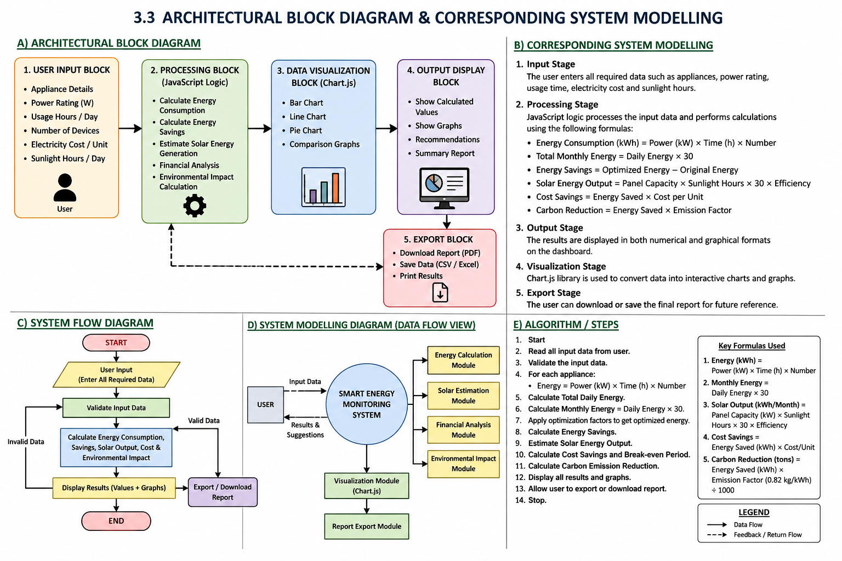
3.3 Architectural block diagram & system modelling

Chapter 4
IMPLEMENTATION

4.1 Overview of system implementation
The proposed Smart Energy Monitoring System is implemented as a web-based application using fundamental front-end technologies such as HTML, CSS, and JavaScript. The system is designed to function entirely on the client side, which means it does not require any backend server, database, or internet connectivity after loading, making it lightweight, cost-effective, and easy to deploy. The implementation begins with the development of a user-friendly interface using HTML for structuring input forms and CSS for enhancing the visual appearance and responsiveness of the application. The interface allows users to conveniently enter essential data such as the power rating of electrical appliances, the number of devices, daily usage duration in hours, electricity cost per unit, and sunlight hours for solar estimation.
Once the user provides the input data, JavaScript plays a crucial role in processing this information. It performs various real-time calculations using predefined formulas, such as computing daily and monthly energy consumption based on power and time, estimating potential energy savings by comparing optimized usage, and calculating solar energy generation using panel capacity and sunlight duration. Additionally, the system may also estimate cost savings and environmental impact, such as reduction in carbon emissions, to provide a more comprehensive analysis of energy usage.
The processed results are then immediately displayed on the user interface without any delay, ensuring a smooth and interactive user experience. To make the output more understandable and visually appealing, the system integrates the Chart.js library for data visualization. This enables the generation of different types of charts such as bar graphs, line charts, and pie charts, which help users easily interpret their energy consumption patterns, savings, and solar output comparisons.
Furthermore, the system includes an export functionality that allows users to download or save their results in a suitable format for future reference or reporting purposes. This feature enhances the usability of the system in academic and practical scenarios. Overall, the implementation focuses on simplicity, efficiency, and usability, ensuring that even users with minimal technical knowledge can operate the system effectively. The combination of real-time computation, interactive visualization, and a clean interface makes the system a practical tool for monitoring, analyzing, and managing energy consumption in an efficient manner.

4.2 Module description

1. User Input Module
- Collects input data from the user
- Inputs include power rating, usage hours, number of devices, cost, sunlight hours
- Provides a simple and user-friendly interface
2. Energy Calculation Module
- Processes input data using JavaScript
- Calculates daily and monthly energy consumption
- Estimates energy usage and savings
- Core module of the system
3. Solar Estimation Module
- Calculates solar energy generation
- Uses sunlight hours and panel capacity
- Helps analyze renewable energy usage
4. Financial Analysis Module
- Calculates electricity cost
- Estimates cost savings
- Helps in budget and expense analysis
5. Data Visualization Module
- Displays results in graphical form
- Uses Chart.js library
- Generates bar charts, pie charts, and line graphs
6. Report / Export Module
- Allows downloading or saving results
- Stores data for future reference
- Improves usability of the system

4.3 Code snippets
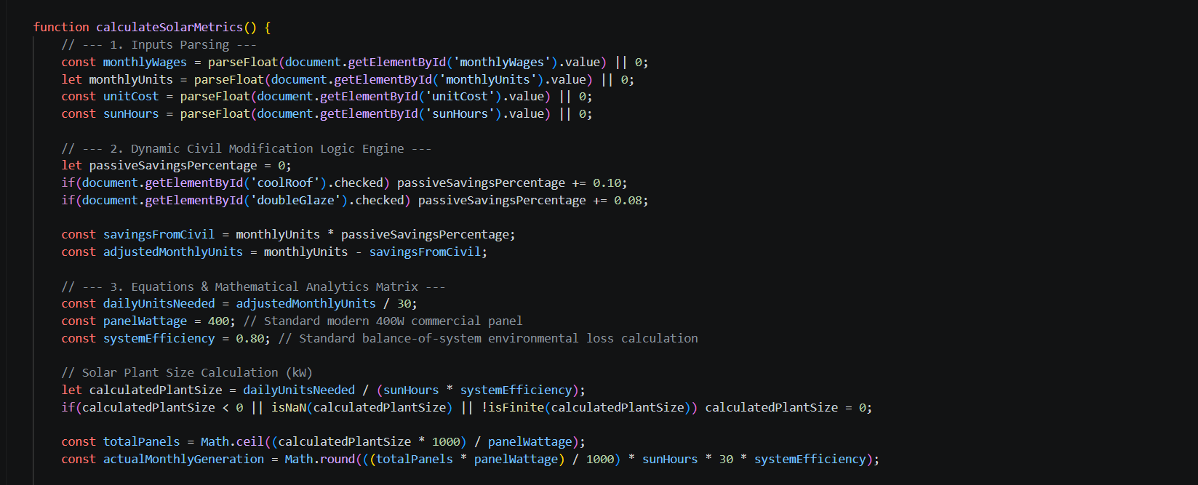
4.3.1 Input, civil logic modification & solar plant size calculations
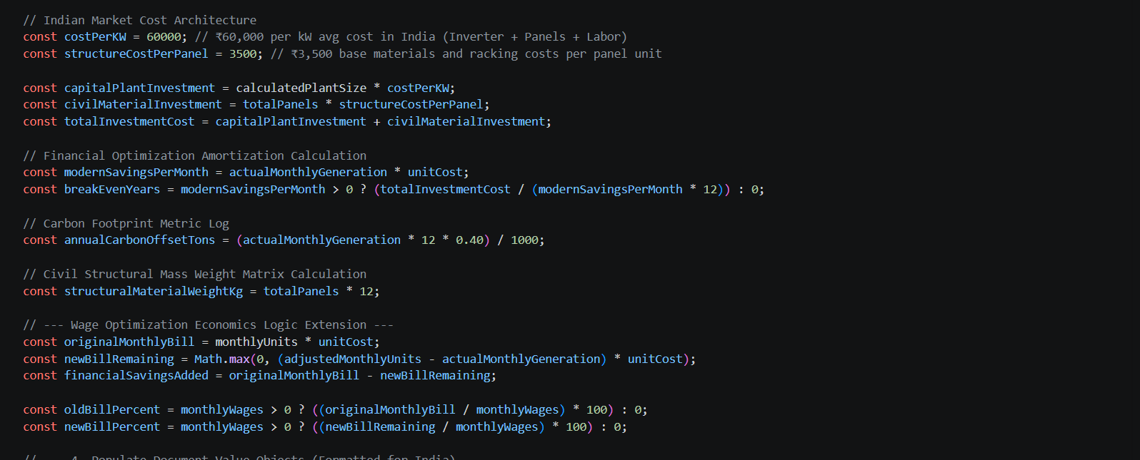
4.3.2 Indian market cost architecture
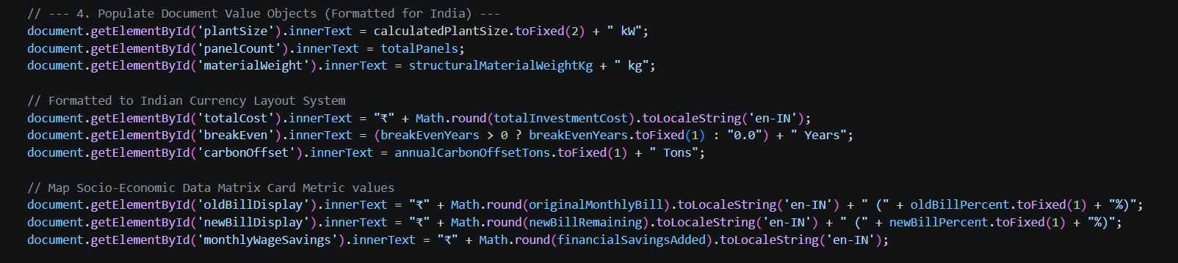
4.3.3 Populate Document value
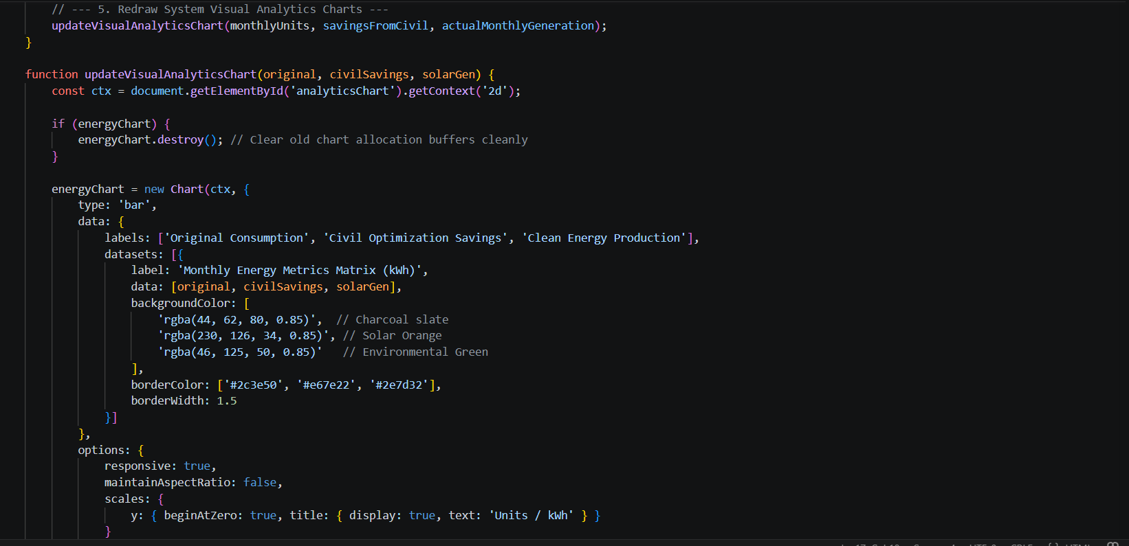
4.3.4 System visual analytics charts
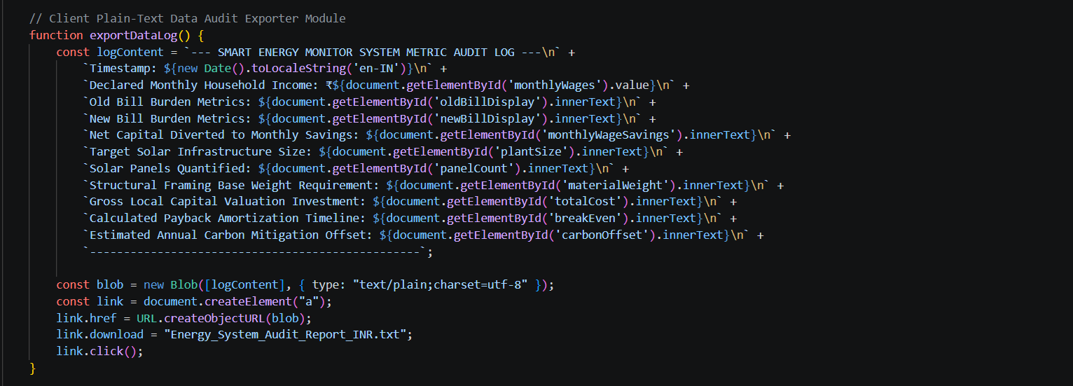
4.3.5 Text data audit exporter module
Chapter 5
RESULTS & DISCUSSIONS
  - Results

The developed system was tested under different conditions by varying the energy consumption, cost per unit, sun hours, and civil optimization techniques. The following observations were obtained:
Test Case 1: Moderate Consumption with Optimization
The system was tested with a monthly energy consumption of 300 kWh, unit cost of ₹8, and 5 sun hours per day. Civil optimization techniques such as cool roof and double glazing were applied. The system reduced the effective energy consumption and calculated an optimal solar plant size. The results showed noticeable savings in electricity cost and a reasonable break-even period. This demonstrates that combining civil techniques with solar energy improves efficiency.
Test Case 2: High Consumption without Optimization
The system was tested with 600 kWh monthly consumption, ₹9 per unit cost, and 6 sun hours per day without applying any civil optimization methods. The system calculated a larger solar plant size and higher installation cost. However, due to high energy usage, the savings were also significant, resulting in a shorter break-even period. This shows that the system performs effectively for high energy demand scenarios.
Test Case 3: Low Consumption Scenario
The system was tested with a low energy consumption of 150 kWh per month, ₹7 per unit cost, and 5 sun hours. Only minimal civil optimization was applied. The system calculated a small solar plant size and lower cost. However, the savings were also limited, leading to a longer break-even period. This indicates that solar installation benefits are comparatively lower for small-scale consumption.
Test Case 4: Full Civil Optimization
The system was tested with 400 kWh consumption, ₹8 per unit cost, and 5 sun hours, with all civil optimization techniques enabled. The energy consumption reduced significantly before solar calculation. This resulted in a smaller required solar plant size and reduced overall cost. The system proved that maximum optimization leads to better efficiency and cost savings.

Discussion
The developed system integrates civil engineering techniques with solar energy estimation to provide an efficient solution for reducing electricity consumption. From the results obtained, it is observed that applying civil optimization methods such as cool roof and double glazing significantly reduces the overall energy demand before installing a solar system. The system dynamically adjusts the solar plant size based on optimized energy consumption, ensuring that the design is both cost-effective and efficient. It also provides detailed insights into installation cost, energy savings, and break-even period, helping users make informed decisions.
Different test cases show that higher energy consumption leads to greater savings and faster return on investment, whereas lower consumption results in smaller benefits. Additionally, the absence of civil optimization increases system size and cost, highlighting the importance of combining both approaches.
Overall, the system demonstrates that integrating passive civil techniques with renewable energy solutions leads to improved performance, reduced costs, and better sustainability.
Advantages:
- Reduces electricity consumption using civil optimization techniques
- Provides accurate solar plant size estimation
- Helps in calculating total installation cost
- Estimates monthly savings and return on investment
- User-friendly and easy to operate
- Supports decision-making for energy management
- Works for different consumption levels (low, medium, high)
- Promotes use of renewable energy (solar power)
- Cost-effective and environmentally friendly solution

Chapter 6
CONCLUSION & FUTURE SCOPE
6.1 Conclusion
The developed system includes a separate HTML page designed for implementing the core functionality of the solar energy calculation. This development page contains the user interface and logic required to collect input parameters such as energy consumption, cost per unit, and sunlight availability, and to display the calculated results.
This HTML page is integrated with the main website by linking it through the homepage, allowing users to easily navigate and access the calculator. The page is structured with proper headings, input fields, and output sections to ensure a user-friendly experience.
By incorporating this development page into the website, the system becomes more interactive and functional, enabling real-time calculations and improving overall usability. This integration also enhances the presentation of the project, making it more organized and professional.

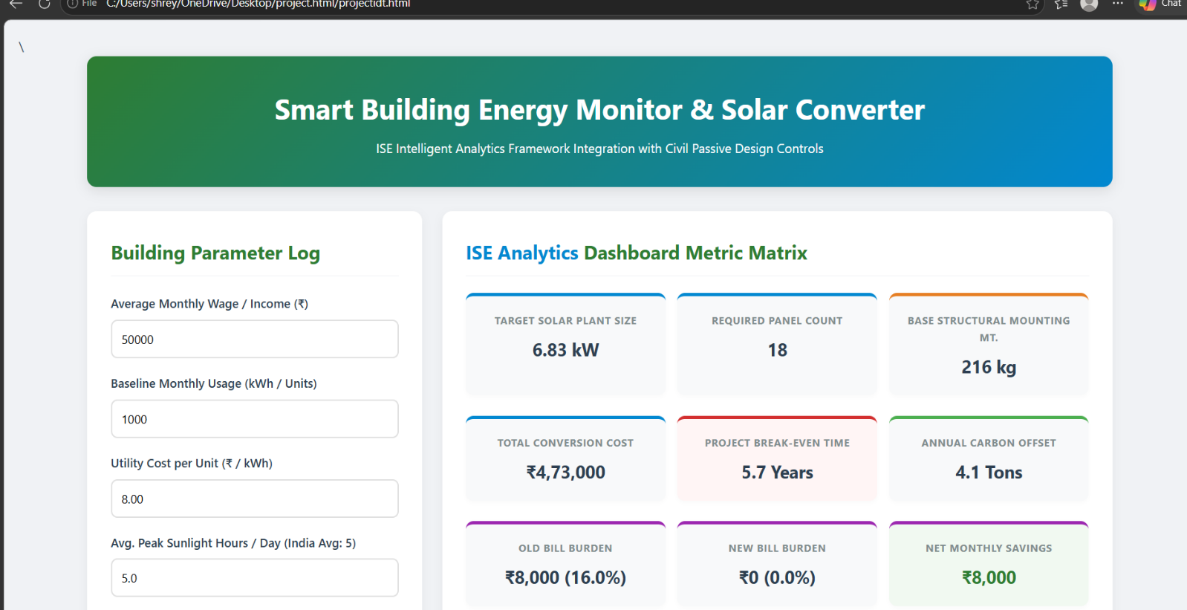
6.1.1 Dashboard along with user inputted data

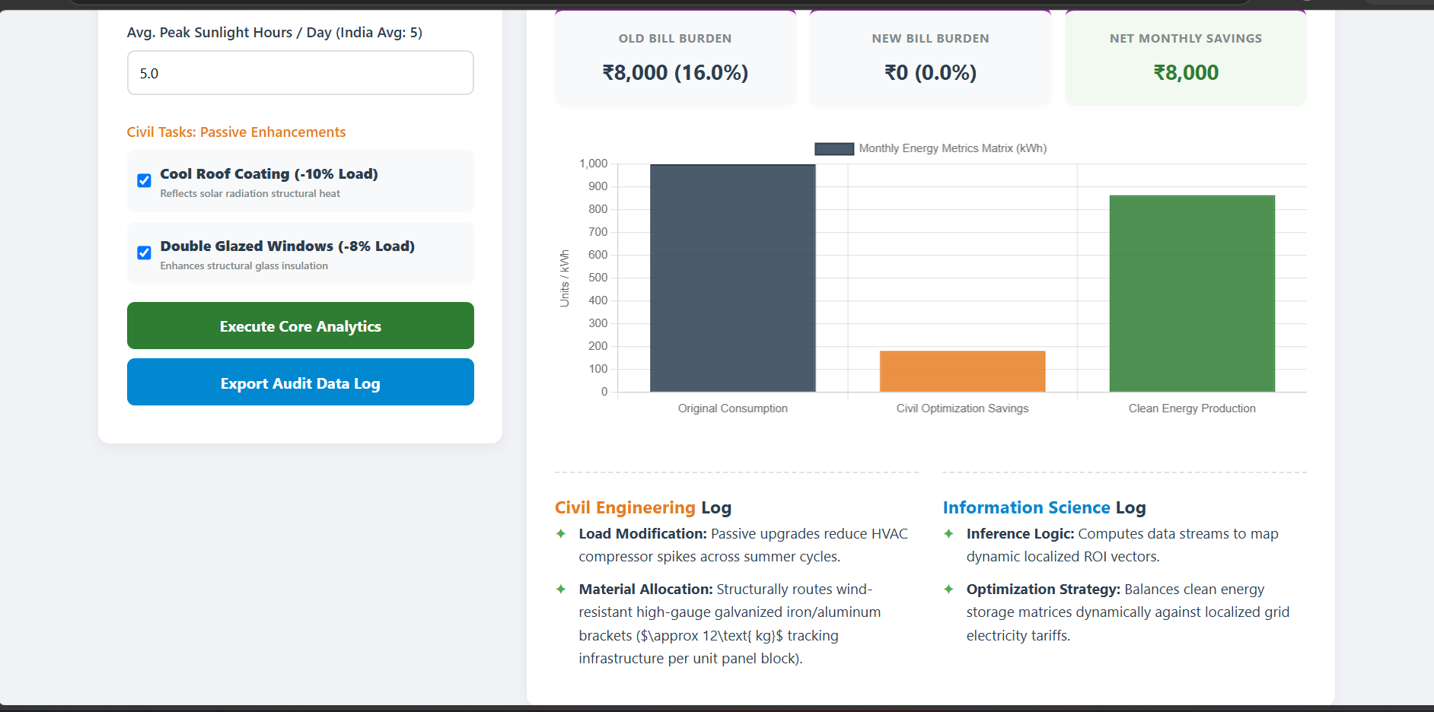
6.1.2 Graphical Analysation
6.2 Future scope
The developed system can be further enhanced to improve its functionality and real-world application. The current implementation uses a web-based dashboard for performing calculations and displaying results; however, several advanced features can be added in the future.
The system can be integrated with real-time weather data to improve the accuracy of solar energy estimation based on actual sunlight conditions. A mobile application version of the dashboard can also be developed to provide better accessibility for users.
Further improvements may include the addition of battery storage calculations to support energy backup systems. The system can also be enhanced using Artificial Intelligence and Machine Learning techniques to predict energy consumption more accurately.
Moreover, IoT-based sensors can be integrated to monitor real-time energy usage and update the dashboard automatically. The project can also be extended to analyze large-scale applications such as commercial and industrial buildings.
Overall, the future scope of the system lies in making it smarter, more automated, and widely applicable for efficient energy management.

REFERENCES

[1] A. Talwariya et al., “Machine Learning and Predictive Analytics for Intelligent Grid Balancing,” IEEE Transactions on Smart Grid, 2023.
[2] M. Khalil and S. A. Sheikh, “Advancing Green Energy Integration in Power Systems for Enhanced Sustainability: A Review,” Sustainable Energy Technologies and Assessments, 2022.
[3] R. Moglen et al., “Macro Optimization Frameworks for Solar Panel Integration in Smart Buildings,” Applied Energy, 2022.
[4] Ahmed et al., “Solar-Powered Smart Buildings: Integrated Energy Management Solution for IoT-Enabled Sustainability,” IEEE Access, 2021.
[5] S. A. Moghaddam et al., “Comprehensive Review and Analysis of Glazing Systems towards Nearly Zero-Energy Buildings,” Journal of Building Engineering, 2021.
[6] V. Anand et al., “Passive Design Controls and Green Building Material Optimization,” Journal of Green Building, 2021.
[7] R. M. Babu et al., “Toward Sustainable and Clean Energy Futures: A Techno-Economic Review of Solar PV Systems,” Renewable and Sustainable Energy Reviews, 2020.
[8] S. Zhao et al., “An Analysis of the Influence of Cool Roof Thermal Parameters on Building Energy Consumption,” Energy and Buildings, 2020.
[9] S. Knuth et al., “Financial Amortization Modelling for Urban Renewable Energy Transitions,” Energy Economics, 2019.
[10] Radhika A et al., “IoT-Based Real-Time Building Energy Monitoring Systems,” International Journal of Engineering Research & Technology, 2019.

APPENDIX

PROJECT SOURCE CODE / LINK:
https://drive.google.com/file/d/1795O4bEo3wp3tOX8aQBdwIGx2WI8salQ/view?usp=drive_link

